After opening studio -> Compute -> compute cluster -> create new compute cluster

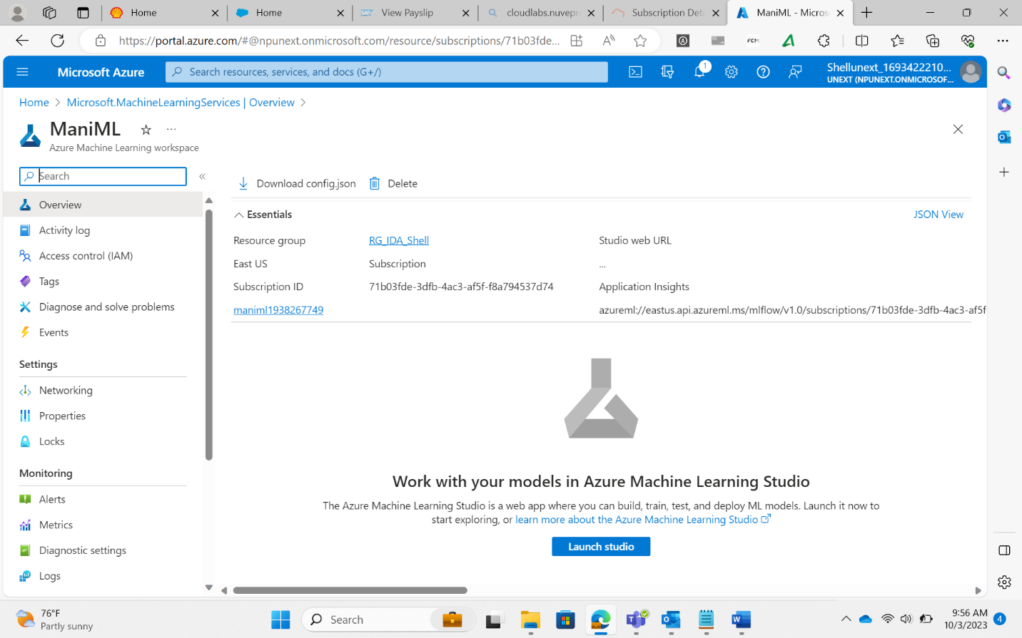

Azure ML Designer